1]

#include<stdio.h>

int main(){

int r,c;

printf("Enter rows and columns: ");

scanf("%d %d",&r,&c);

int a[50][50];

printf("Enter elements:\n");

for(int i=0;i<r;i++)

for (int j=0;j<c;j++)

scanf("%d",&a[i][j]);

int found=0;

for(int i=0;i<r;i++){

int rowMin=a[i][0],colIndex=0;

for(int j=1;j<c;j++){

if(a[i][j]<rowMin){

rowMin=a[i][j];

colIndex=j;

}

}

int Saddle=1;

for(int k=0;k<r;k++){

if(a[k][colIndex]>rowMin){

Saddle=0;

break;

}

}

if(Saddle){

printf("Saddle Point found: %d\n",rowMin);

found=1;

}

}

if(!found)

printf("No Saddle Point found\n");

return 0;

}

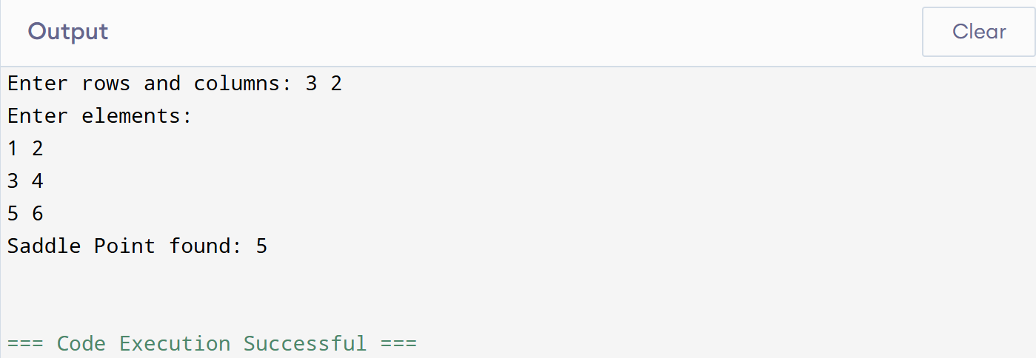

2]

#include<stdio.h>

int main(){

int r,c;

printf("Enter rows and columns: ");

scanf("%d %d",&r,&c);

int a[50][50];

printf("Enter elements:\n");

for(int i=0;i<r;i++)

for(int j=0;j<c;j++)

scanf("%d",&a[i][j]);

int top=0,bottom=r-1,left=0,right=c-1;

printf("Spiral Order: ");

while(top<=bottom && left<=right){

for(int i=left;i<=right;i++)

printf("%d ",a[top][i]);

top++;

for(int i=top;i<=bottom;i++)

printf("%d ",a[i][right]);

right--;

if(top<=bottom){

for(int i=right;i>=left;i--)

printf("%d ",a[bottom][i]);

bottom--;

}

if(left<=right){

for(int i=bottom;i>=top;i--)

printf("%d ",a[i][left]);

left++;

}

}

return 0;

}

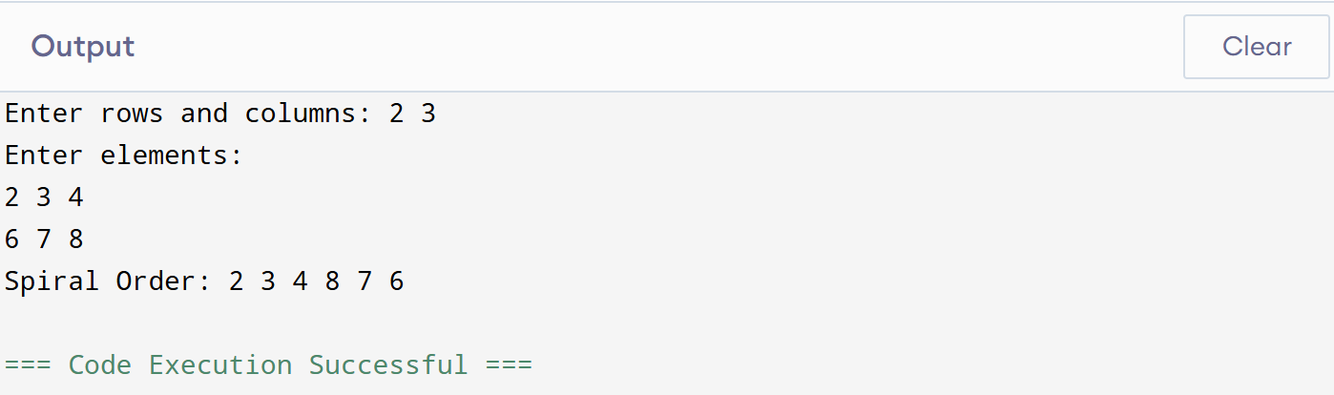

3]

#include<stdio.h>

int main(){

int n;

printf("Enter n: ");

scanf("%d",&n);

int a[50][50];

int top=0,bottom=n-1,left=0,right=n-1;

int num=1;

while(top<=bottom && left<=right){

for(int i=left;i<=right;i++)

a[top][i]=num++;

top++;

for(int i=top;i<=bottom;i++)

a[i][right]=num++;

right--;

for(int i=right;i>=left;i--)

a[bottom][i]=num++;

bottom--;

for(int i=bottom;i>=top;i--)

a[i][left]=num++;

left++;

}

printf("Spiral Matrix:\n");

for(int i=0;i<n;i++){

for(int j=0;j<n;j++)

printf("%3d ",a[i][j]);

printf("\n");

}

return 0;

}

